Advanced Deliverables (low priority):
These are the ones that are implemented and the deviations from its original
Video feature:
Implemented in the carousel. Client will be able to upload videos from the database. Videos will have no sound, so no sound controls. Cannot stop/pause but no need to if it doesn’t play any sound.

Add and Remove from Carousel:
Implemented but it’s a bit different from how it is specified in Functional Requirements. It is made to be more intuitive

Adding to carousel:

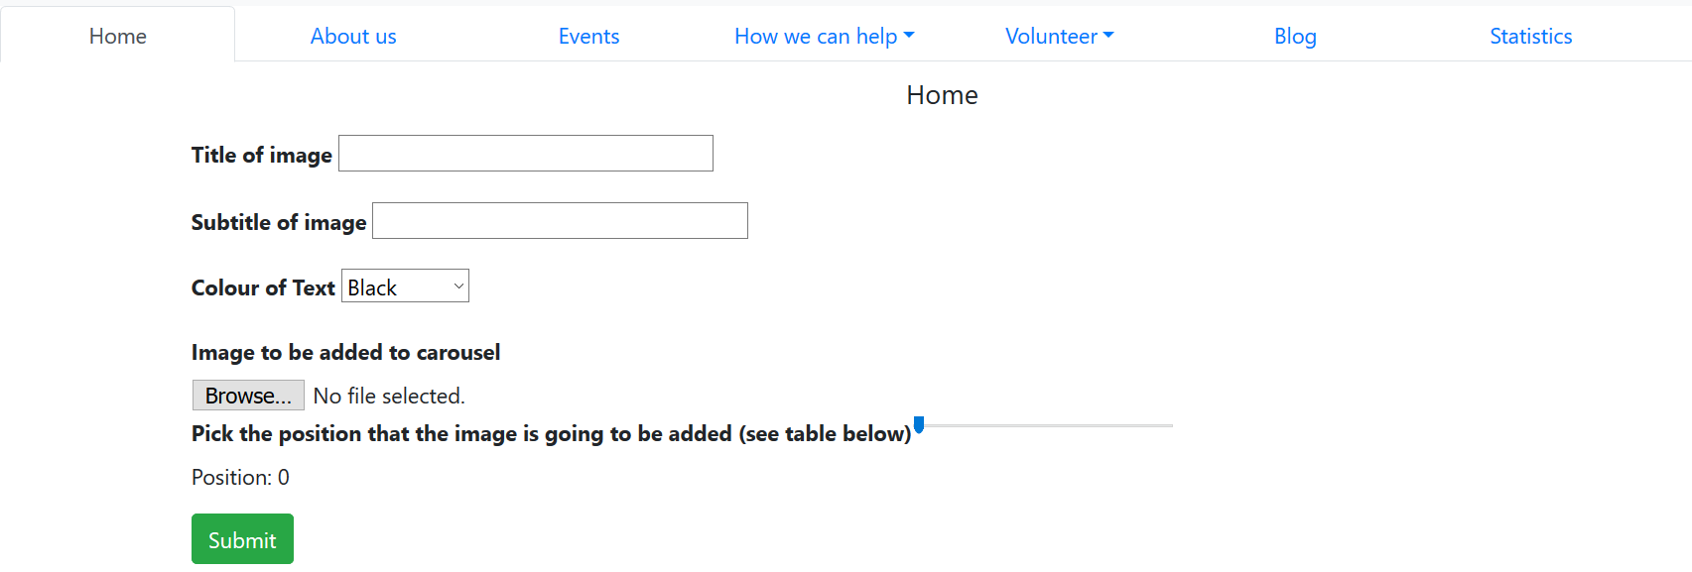

Deleting from carousel (3.mp4 is a video that’s why it appers small)
